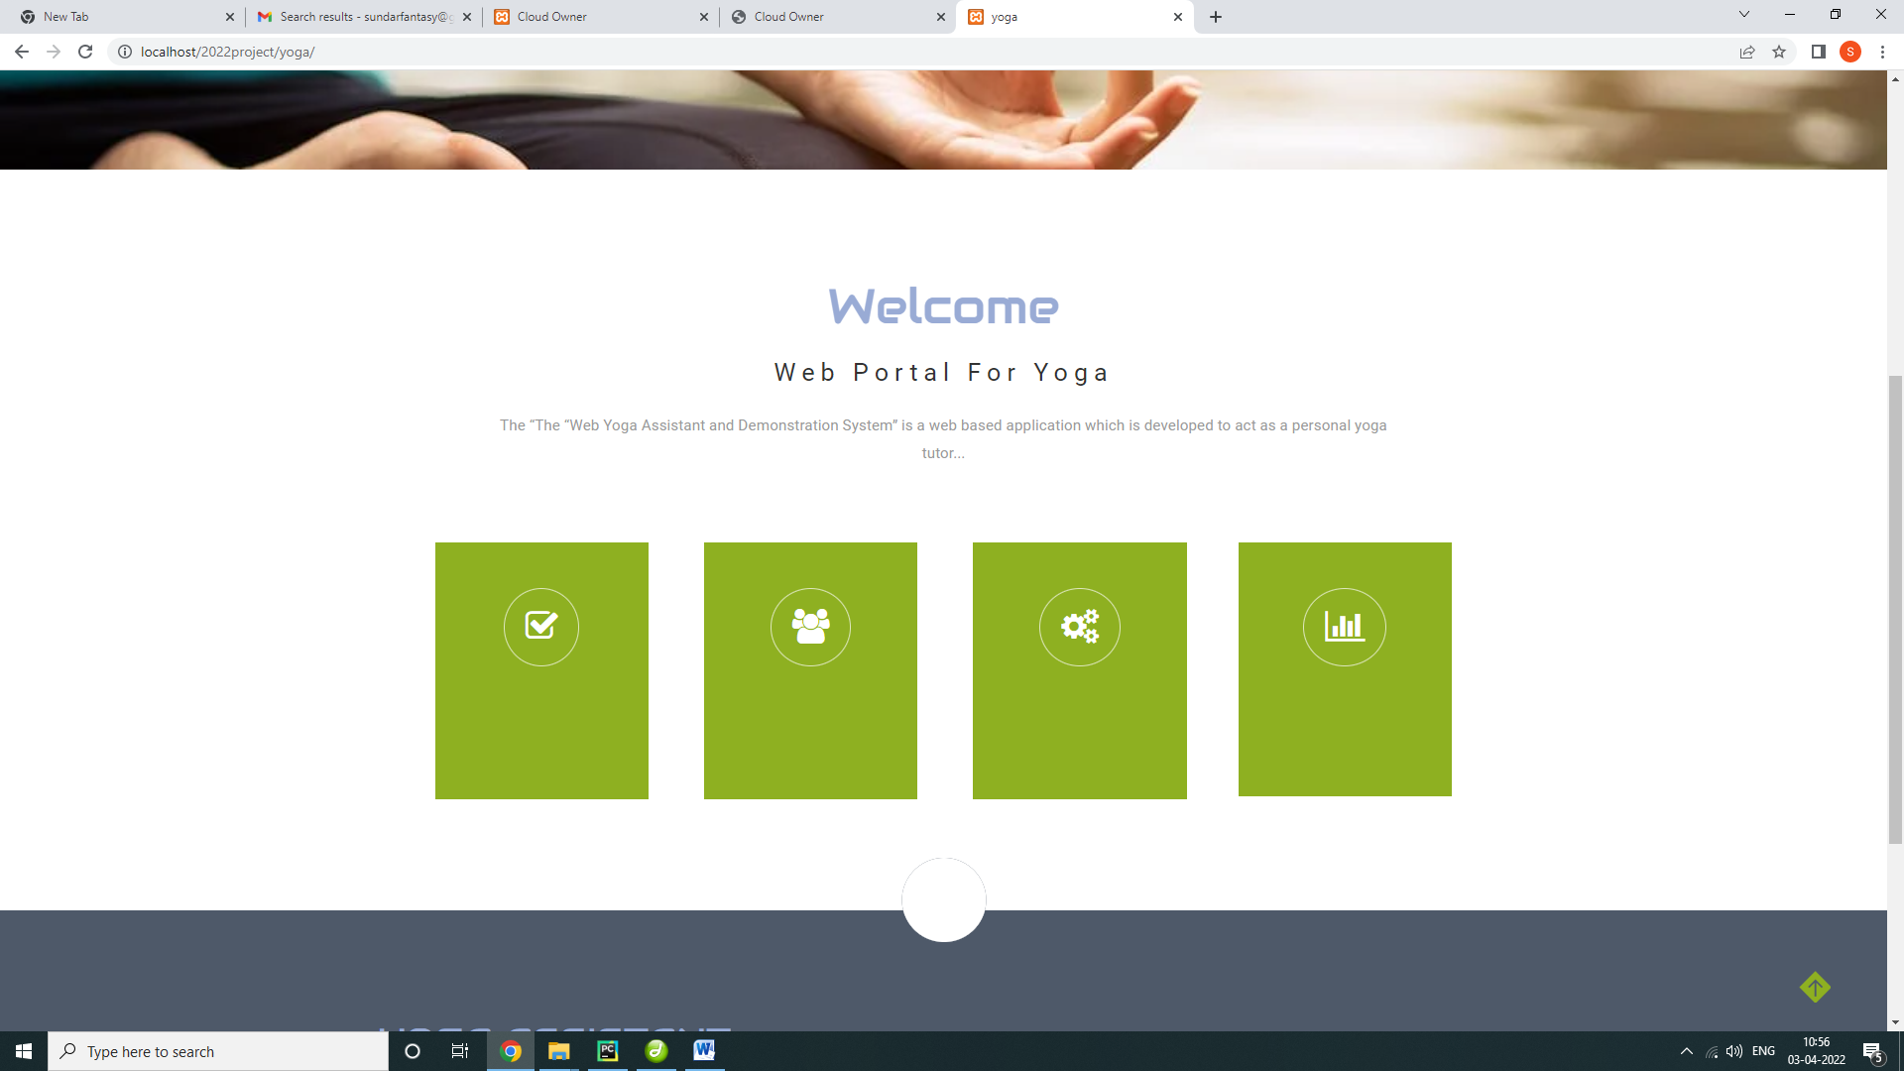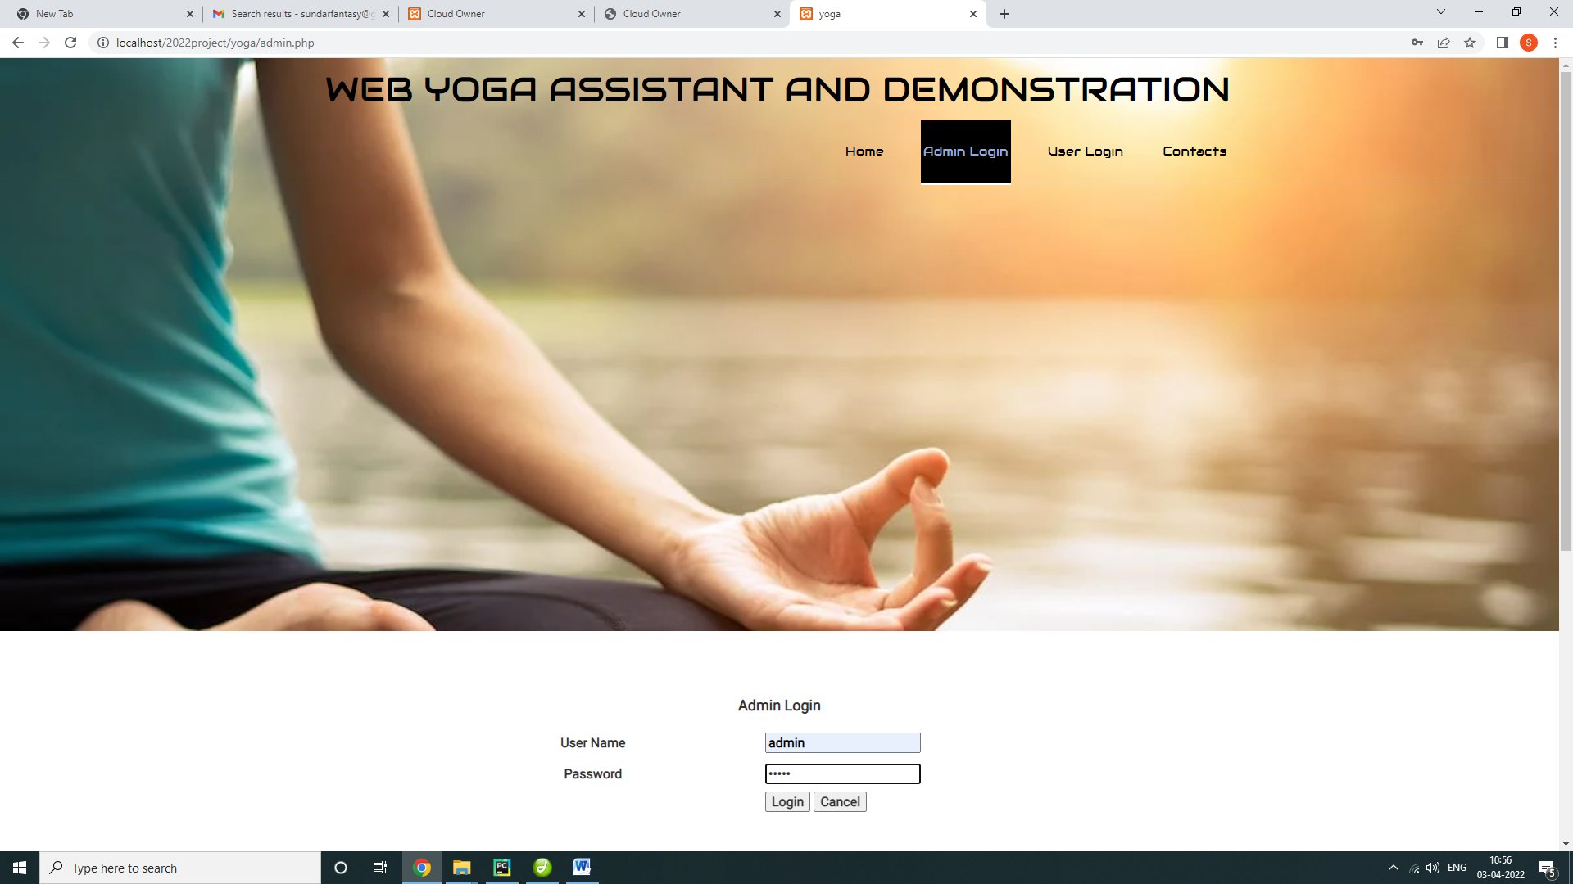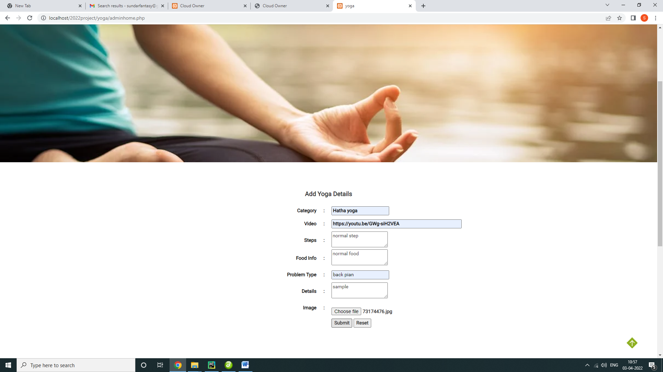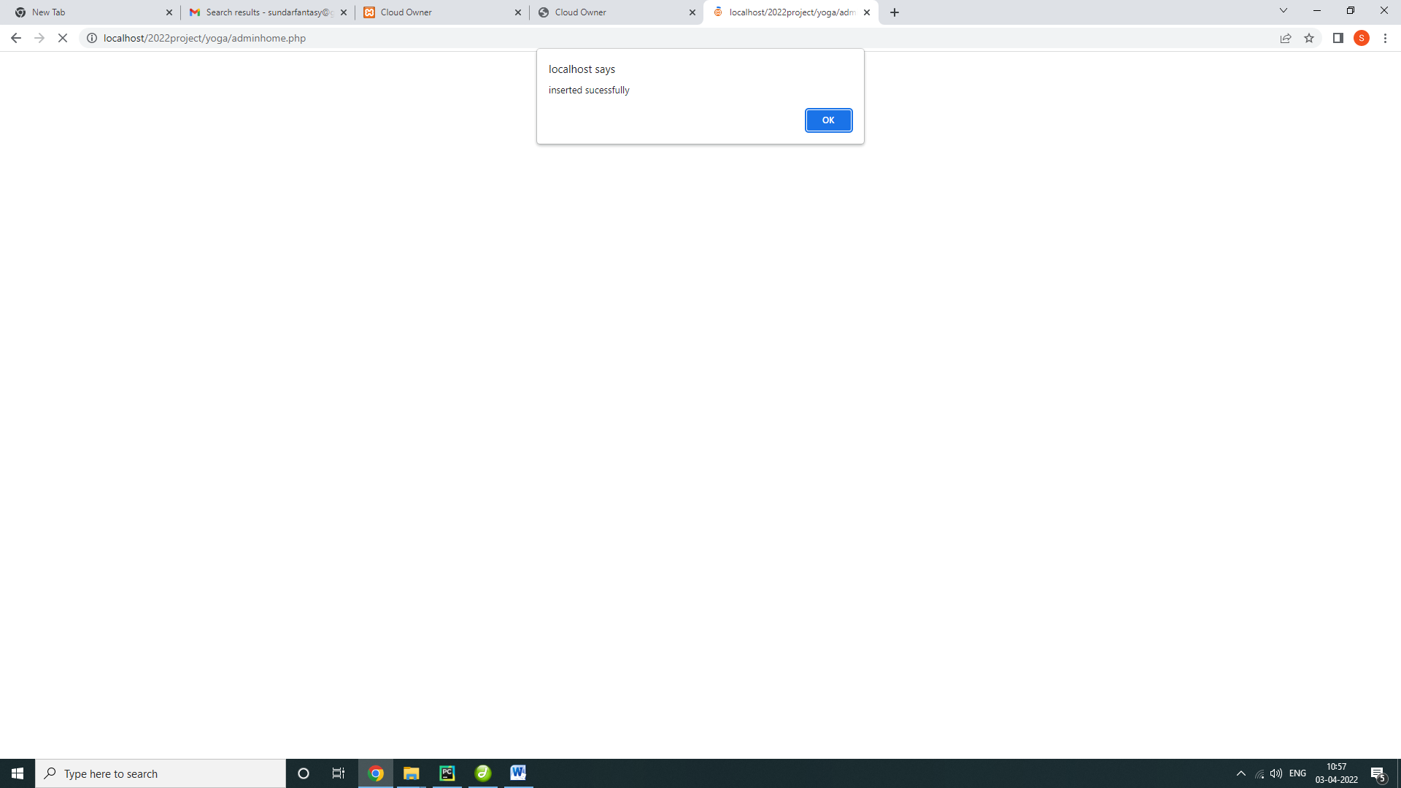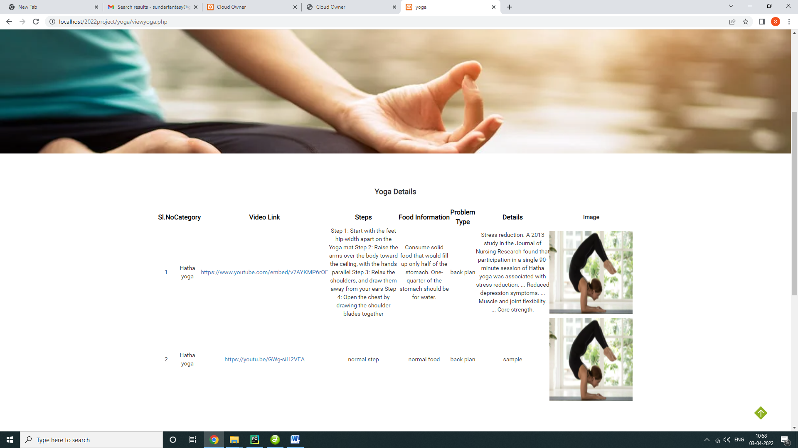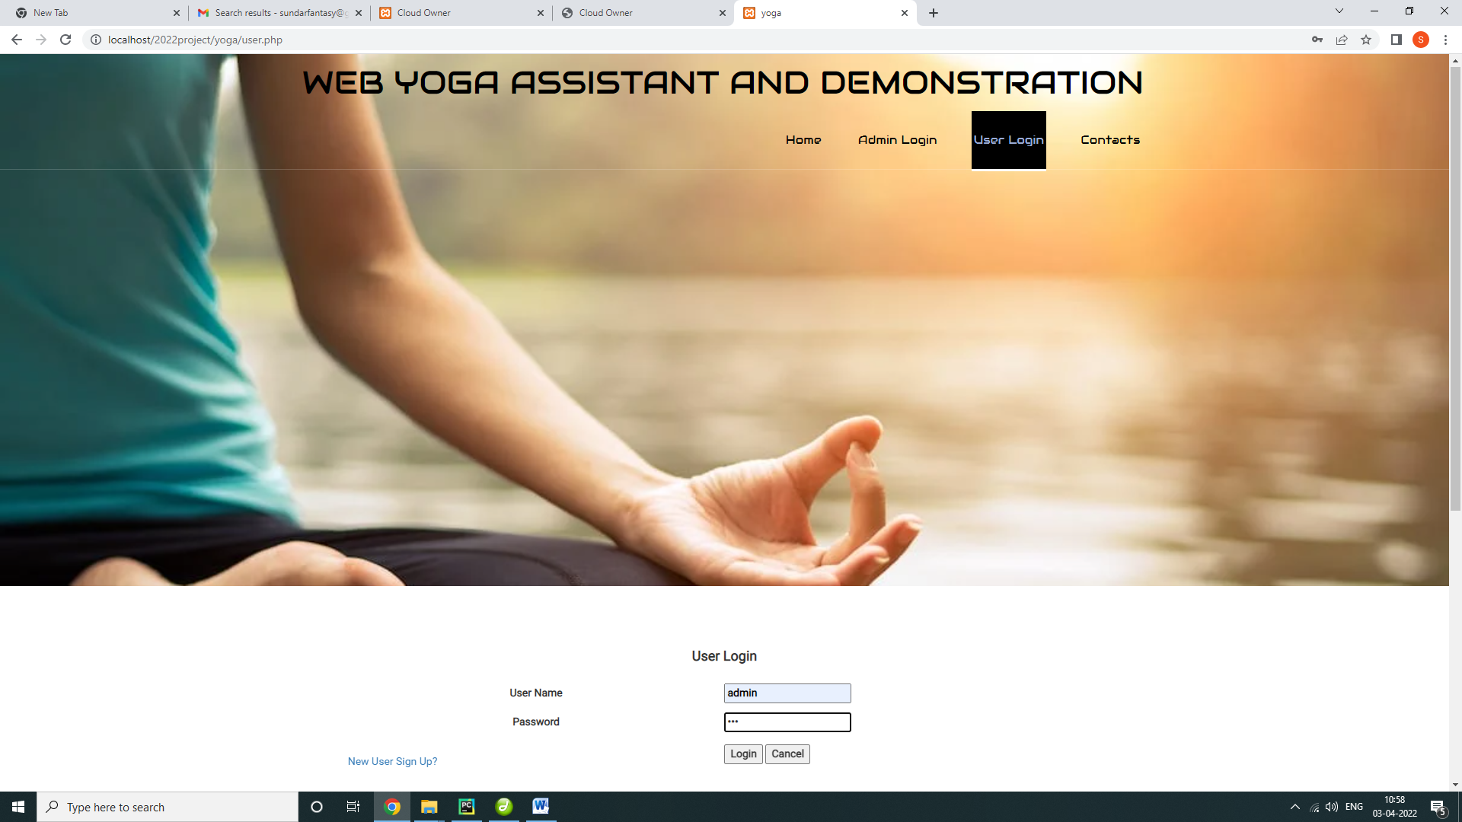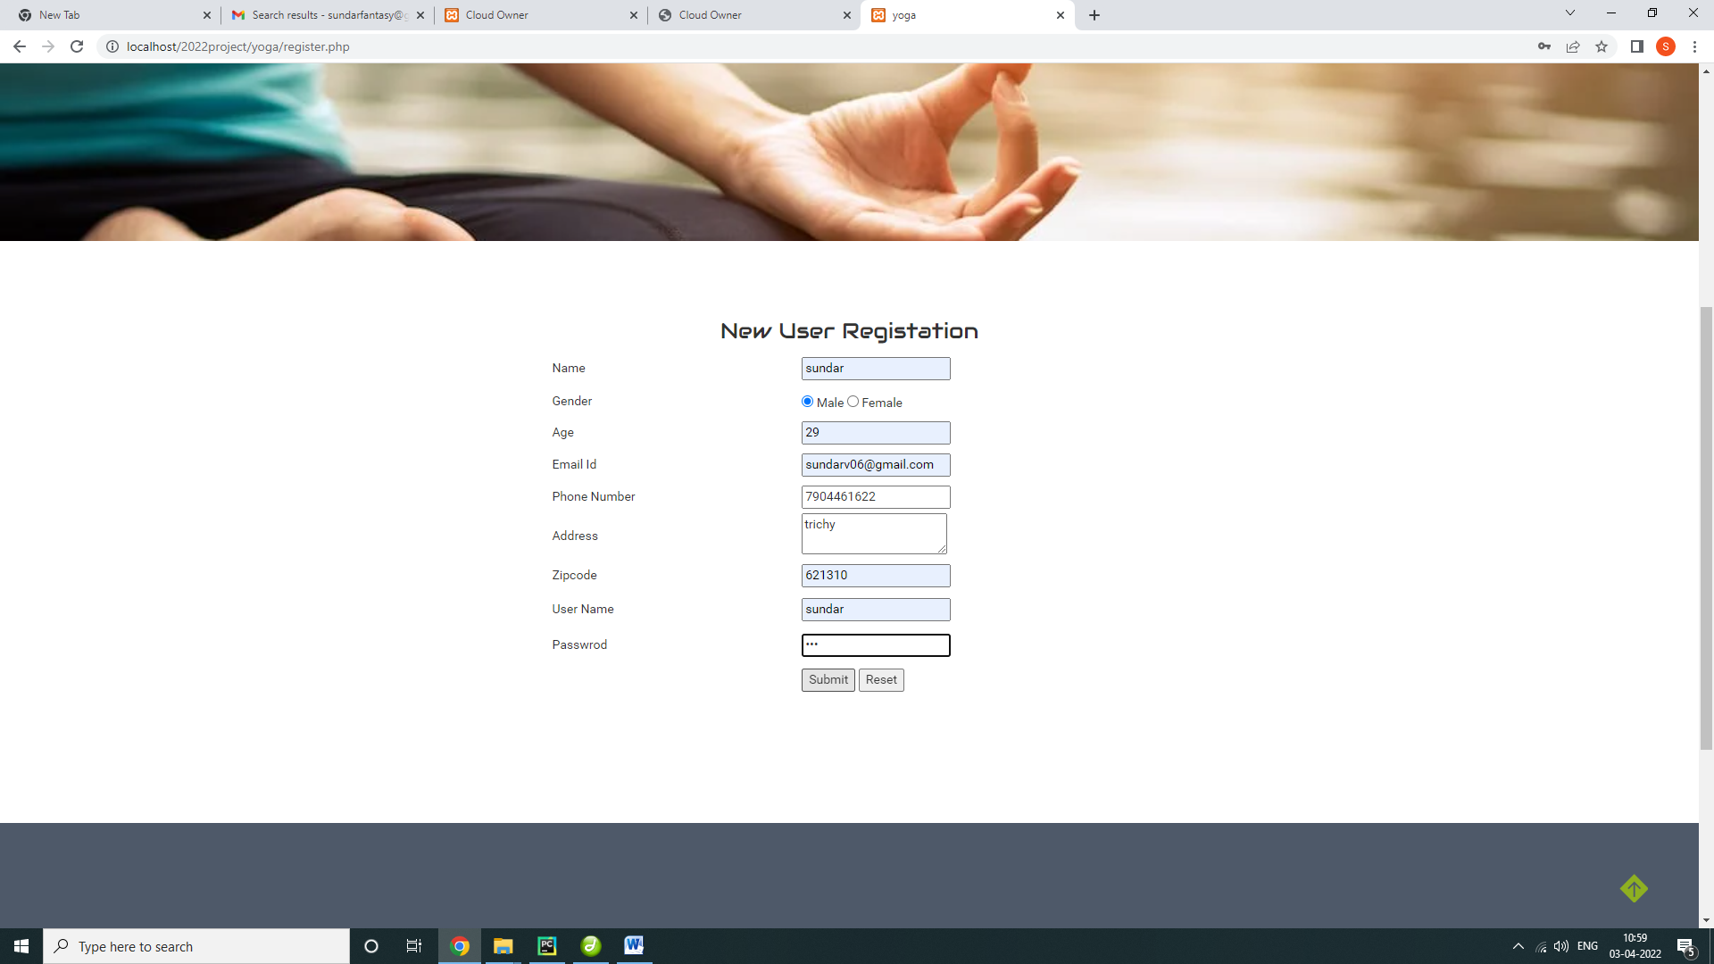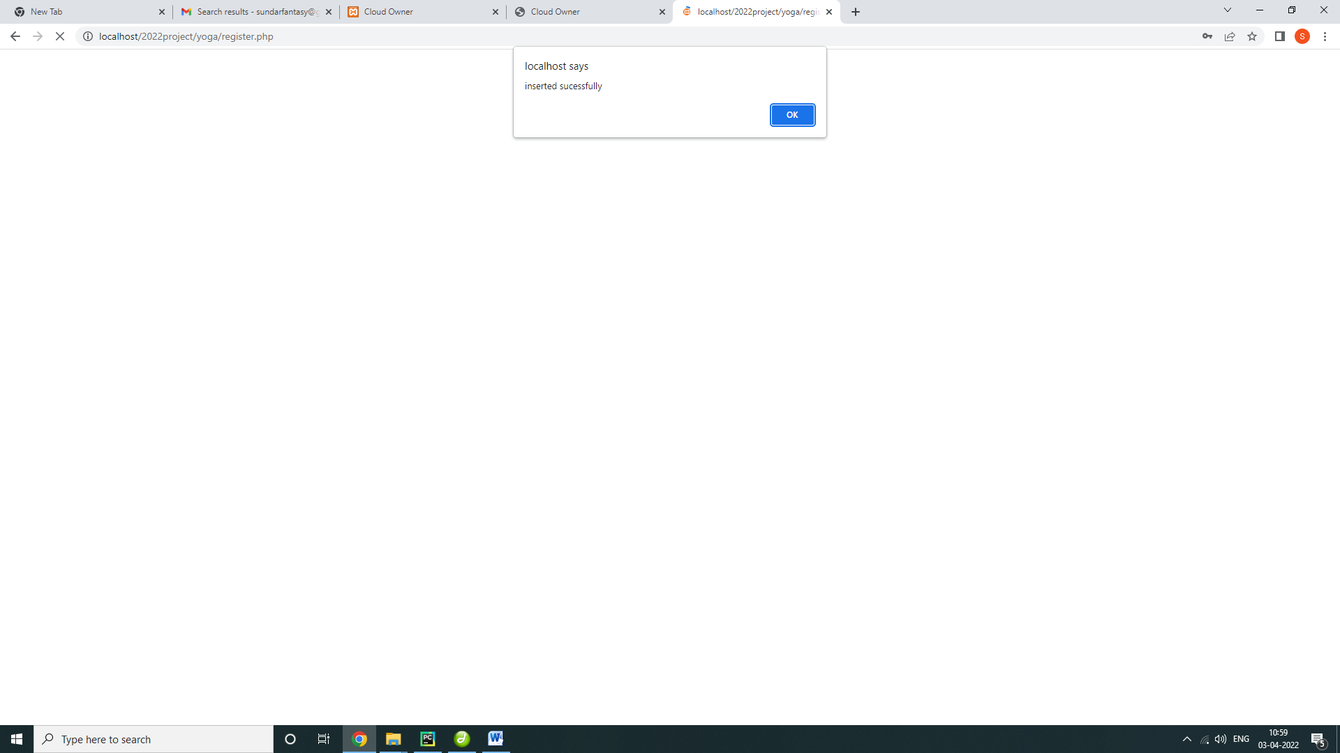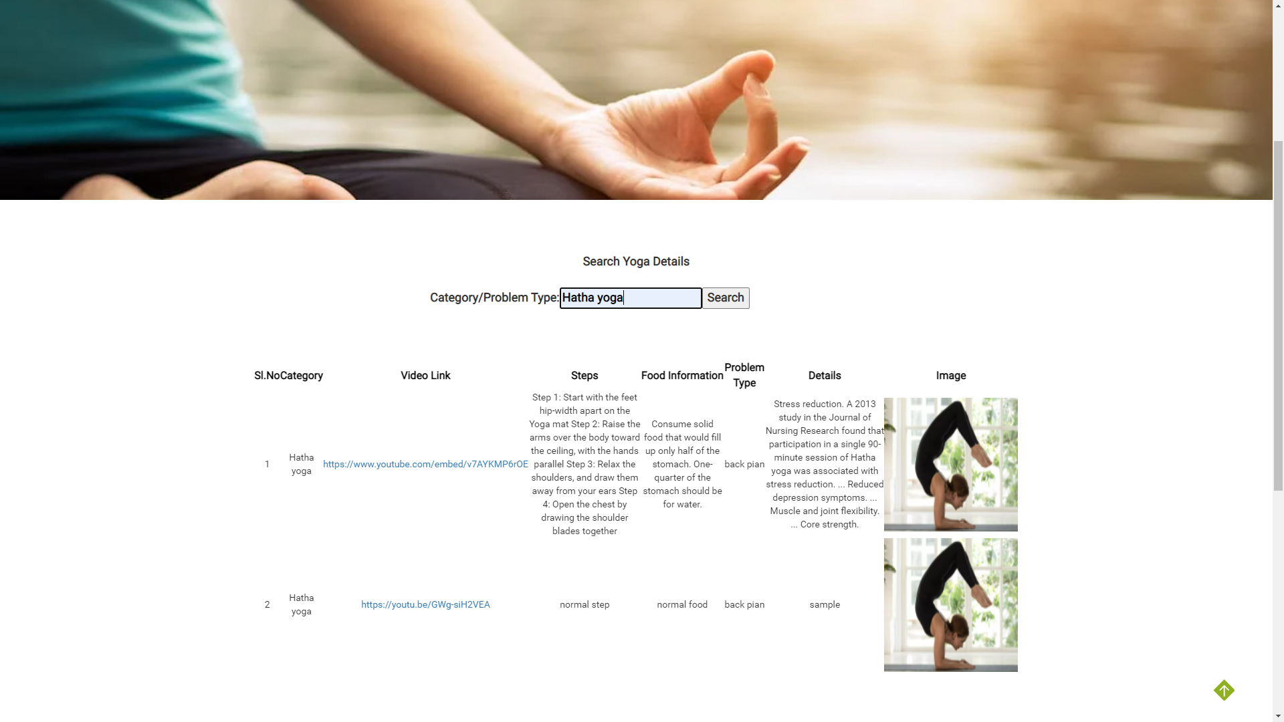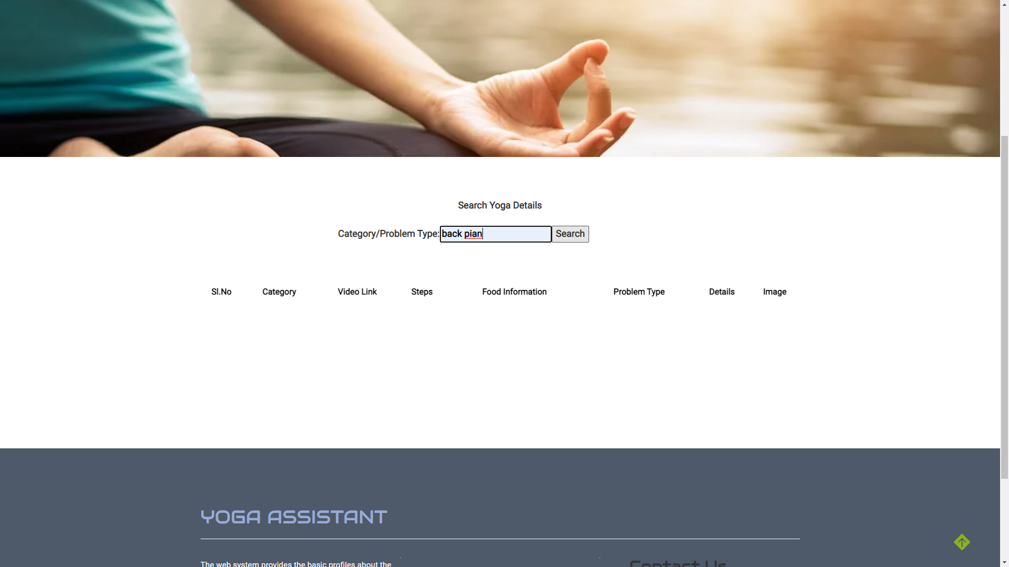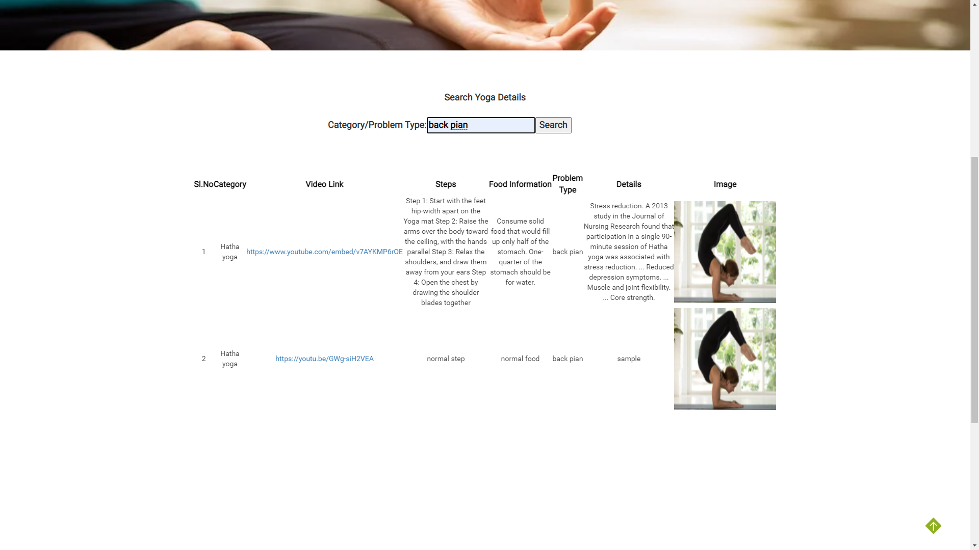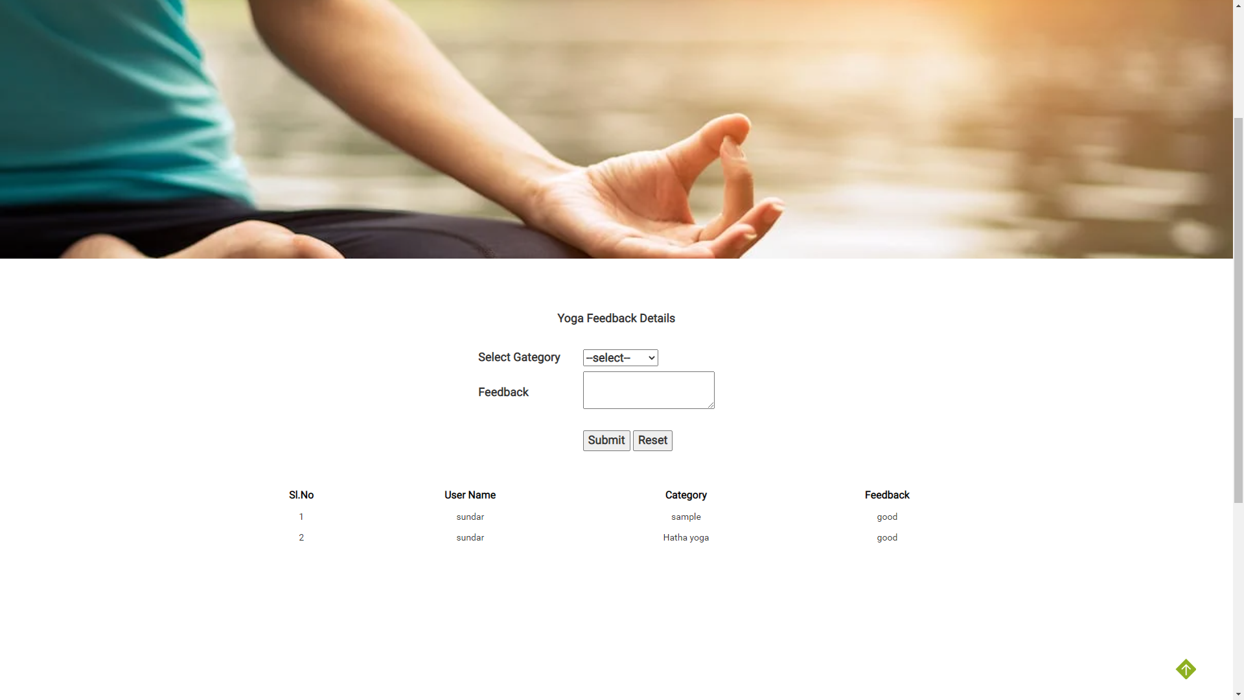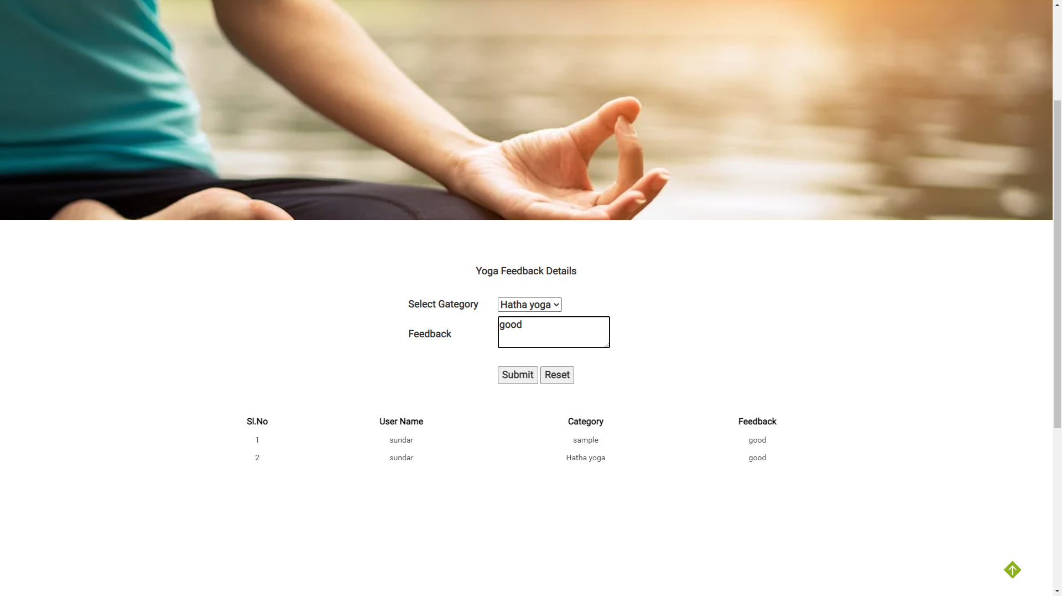

Database connection

<?php

$connect=mysql_connect("localhost","root","");

mysql_select_db("yoga",$connect);

?>

Admin login

<?php

include("dbconnect.php");

extract($_POST);

session_start();

if(isset($_POST['btn']))

{

$qry=mysql_query("select * from admin where uname='$uname' && password='$password'");

$num=mysql_num_rows($qry);

if($num==1)

{

?>

<script>alert('welcome to admin home page');

</script>

<?php

header("location:adminhome.php");

}

else

{

echo "<script>alert('User Name Password Wrong.....')</script>";

}

}

?>

Userlogin

<?php

include("dbconnect.php");

extract($_POST);

session_start();

if(isset($_POST['btn']))

{

$qry=mysql_query("select * from register where uname='$uname' && password='$password'");

$num=mysql_num_rows($qry);

if($num==1)

{

$qry=mysql_query("select * from register where uname='$uname' && password='$password'");

$row=mysql_fetch_assoc($qry);

$_SESSION['uid']=$row['id'];

?>

<script>alert('welcome to User home page');

</script>

<?php

header("location:userhome.php");

}

else

{

echo "<script>alert('User Name Password Wrong.....')</script>";

}

}

?>

Userregister

<?php

include("dbconnect.php");

extract($_POST);

session_start();

if(isset($_POST['btn']))

{

$max_qry = mysql_query("select max(id) from register");

$max_row = mysql_fetch_array($max_qry);

$id=$max_row['max(id)']+1;

$qry=mysql_query("insert into register values('$id','$name','$gender','$age','$email','$phone','$address','$zip','$uname','$psw')");

if($qry)

{

echo "<script>alert('inserted sucessfully')</script>";

}

else

{

echo "failed";

}

}

?>

Add yoga information

<?php

include("dbconnect.php");

extract($_POST);

session_start();

if(isset($_POST['btn']))

{

$max_qry = mysql_query("select max(id) from yoga");

$max_row = mysql_fetch_array($max_qry);

$id=$max_row['max(id)']+1;

$imgpath=$_FILES['file']['name'];

$errors= array();

$fname = $_FILES['file']['name'];

// $file_size =$_FILES['image']['size'];

$file_tmp =$_FILES['file']['tmp_name'];

// $file_type=$_FILES['image']['type'];

move_uploaded_file($_FILES['file']['tmp_name'],"images/".$fname);

$qry=mysql_query("insert into yoga values('$id','$cat','$vlink','$steps','$food','$problem','$details','$fname')");

if($qry)

{

echo "<script>alert('inserted sucessfully')</script>";

}

else

{

echo "failed";

}

}

?>

View User Details

<?php

include("dbconnect.php");

extract($_POST);

session_start();

?> <form id="form1" name="form1" method="post" action="">

<table width="46%" border="0" align="center">

<tr>

<td width="100%" rowspan="1"><div align="center" class="style1">

<p>User Details </p>

<p>&nbsp;</p>

</div></td>

</tr>

</table>

<table width="60%" border="0" align="center">

<tr>

<td height="35"><div align="center" class="style4">Sl.No</div></td>

<td><div align="center" class="style4">Name</div></td>

<td><div align="center" class="style4">Gender</div></td>

<td><div align="center" class="style4">Age</div></td>

<td><div align="center" class="style4">Address</div></td>

<td><div align="center" class="style4">Email Id </div></td>

<td><div align="center" class="style4">Phone Number </div></td>

</tr>

<?php

$i=1;

$qry=mysql_query("select * from register");

while($row=mysql_fetch_array($qry))

{

?>

<tr>

<td height="44"><div align="center"><?php echo $i;?></div></td>

<td><div align="center"><?php echo $row['name'];?></div></td>

<td><div align="center"><?php echo $row['gender'];?></div></td>

<td><div align="center"><?php echo $row['age'];?></div></td>

<td><div align="center"><?php echo $row['address'];?></div></td>

<td><div align="center"><?php echo $row['email'];?></div></td>

<td><div align="center"><?php echo $row['pnumber'];?></div></td>

</tr>

<?php

$i++;

}

?>

<tr>

<td>&nbsp;</td>

<td>&nbsp;</td>

<td>&nbsp;</td>

<td>&nbsp;</td>

<td>&nbsp;</td>

<td>&nbsp;</td>

<td>&nbsp;</td>

</tr>

<tr>

<td>&nbsp;</td>

<td>&nbsp;</td>

<td>&nbsp;</td>

<td>&nbsp;</td>

<td>&nbsp;</td>

<td>&nbsp;</td>

<td>&nbsp;</td>

</tr>

<tr>

<td>&nbsp;</td>

<td>&nbsp;</td>

<td>&nbsp;</td>

<td>&nbsp;</td>

<td>&nbsp;</td>

<td>&nbsp;</td>

<td>&nbsp;</td>

</tr>

<tr>

<td>&nbsp;</td>

<td>&nbsp;</td>

<td>&nbsp;</td>

<td>&nbsp;</td>

<td>&nbsp;</td>

<td>&nbsp;</td>

<td>&nbsp;</td>

</tr>

<tr>

<td>&nbsp;</td>

<td>&nbsp;</td>

<td>&nbsp;</td>

<td>&nbsp;</td>

<td>&nbsp;</td>

<td>&nbsp;</td>

<td>&nbsp;</td>

</tr>

<tr>

<td>&nbsp;</td>

<td>&nbsp;</td>

<td>&nbsp;</td>

<td>&nbsp;</td>

<td>&nbsp;</td>

<td>&nbsp;</td>

<td>&nbsp;</td>

</tr>

</table>

<p>&nbsp;</p>

</form>

View yoga details

<?php

include("dbconnect.php");

extract($_POST);

session_start();

?> <form id="form1" name="form1" method="post" action="">

<table width="46%" border="0" align="center">

<tr>

<td width="100%" rowspan="1"><div align="center" class="style1">

<p>Yoga Details </p>

<p>&nbsp;</p>

</div></td>

</tr>

</table>

<table width="60%" border="0" align="center">

<tr>

<td height="35"><div align="center" class="style4">Sl.No</div></td>

<td><div align="center" class="style4">Category</div></td>

<td><div align="center" class="style4">Video Link </div></td>

<td><div align="center" class="style4">Steps</div></td>

<td><div align="center" class="style4">Food Information </div></td>

<td><div align="center" class="style4">Problem Type </div></td>

<td><div align="center" class="style4">Details </div></td>

<td><div align="center"><strong>Image</strong></div></td>

</tr>

<?php

$i=1;

$qry=mysql_query("select * from yoga");

while($row=mysql_fetch_array($qry))

{

?>

<tr>

<td height="32"><div align="center"><?php echo $i;?></div></td>

<td><div align="center"><?php echo $row['cat'];?></div></td>

<td><div align="center"><a href="video.php?link=<?php echo $row['vlink'];?>"><?php echo $row['vlink'];?></a></div></td>

<td><div align="center"><?php echo $row['steps'];?></div></td>

<td><div align="center"><?php echo $row['food'];?></div></td>

<td><div align="center"><?php echo $row['ptype'];?></div></td>

<td><div align="center"><?php echo $row['details'];?></div></td>

<td><div align="center"><img src="images\<?php echo $row['image'];?>" width="200" height="200"></div></td>

</tr>

<?php

$i++;

}

?>

View Feedback

<?php

include("dbconnect.php");

extract($_POST);

session_start();

?>

<form id="form1" name="form1" method="post" action="">

<table width="46%" border="0" align="center">

<tr>

<td width="100%" rowspan="1"><div align="center" class="style1">

<p>User Feedback Details </p>

<p>&nbsp;</p>

</div></td>

</tr>

</table>

<table width="50%" border="0" align="center">

<tr>

<td height="35"><div align="center" class="style4">Sl.No</div></td>

<td><div align="center" class="style4">Category</div></td>

<td><div align="center" class="style4">User Name </div></td>

<td><div align="center" class="style4">Feedback</div></td>

</tr>

<?php

$i=1;

$qry=mysql_query("select * from feedback");

while($row=mysql_fetch_array($qry))

{

?>

<tr>

<td height="32"><div align="center"><?php echo $i;?></div></td>

<td><div align="center"><?php echo $row['cat'];?></div></td>

<td><div align="center"><?php echo $row['uname'];?></div></td>

<td><div align="center"><?php echo $row['feedback'];?></div></td>

</tr>

<?php

$i++;

}

?>

User home

<?php

include("dbconnect.php");

extract($_POST);

session_start();

?> <table width="60%" border="0" align="center">

<tr>

<td height="35"><div align="center" class="style4">Sl.No</div></td>

<td><div align="center" class="style4">Category</div></td>

<td><div align="center" class="style4">Video Link </div></td>

<td><div align="center" class="style4">Steps</div></td>

<td><div align="center" class="style4">Food Information </div></td>

<td><div align="center" class="style4">Problem Type </div></td>

<td><div align="center" class="style4">Details </div></td>

<td><div align="center" class="style4">Image</div></td>

</tr>

<?php

if(isset($_POST['btn']))

{

$i=1;

$qry=mysql_query("select * from yoga where cat='$search' or ptype='$search'");

while($row=mysql_fetch_array($qry))

{

?>

<tr>

<td height="32"><div align="center"><?php echo $i;?></div></td>

<td><div align="center"><?php echo $row['cat'];?></div></td>

<td><div align="center"><a href="video1.php?link=<?php echo $row['vlink'];?>"><?php echo $row['vlink'];?></a></div></td>

<td><div align="center"><?php echo $row['steps'];?></div></td>

<td><div align="center"><?php echo $row['food'];?></div></td>

<td><div align="center"><?php echo $row['ptype'];?></div></td>

<td><div align="center"><?php echo $row['details'];?></div></td>

<td><div align="center"><img src="images\<?php echo $row['image'];?>" width="200" height="200"></div></td>

</tr>

<?php

$i++;

}

}

?>

<tr>

<td>&nbsp;</td>

<td>&nbsp;</td>

<td>&nbsp;</td>

<td>&nbsp;</td>

<td>&nbsp;</td>

<td>&nbsp;</td>

<td>&nbsp;</td>

<td>&nbsp;</td>

</tr>

<tr>

<td>&nbsp;</td>

<td>&nbsp;</td>

<td>&nbsp;</td>

<td>&nbsp;</td>

<td>&nbsp;</td>

<td>&nbsp;</td>

<td>&nbsp;</td>

<td>&nbsp;</td>

</tr>

<tr>

<td>&nbsp;</td>

<td>&nbsp;</td>

<td>&nbsp;</td>

<td>&nbsp;</td>

<td>&nbsp;</td>

<td>&nbsp;</td>

<td>&nbsp;</td>

<td>&nbsp;</td>

</tr>

<tr>

<td>&nbsp;</td>

<td>&nbsp;</td>

<td>&nbsp;</td>

<td>&nbsp;</td>

<td>&nbsp;</td>

<td>&nbsp;</td>

<td>&nbsp;</td>

<td>&nbsp;</td>

</tr>

<tr>

<td>&nbsp;</td>

<td>&nbsp;</td>

<td>&nbsp;</td>

<td>&nbsp;</td>

<td>&nbsp;</td>

<td>&nbsp;</td>

<td>&nbsp;</td>

<td>&nbsp;</td>

</tr>

<tr>

<td>&nbsp;</td>

<td>&nbsp;</td>

<td>&nbsp;</td>

<td>&nbsp;</td>

<td>&nbsp;</td>

<td>&nbsp;</td>

<td>&nbsp;</td>

<td>&nbsp;</td>

</tr>

</table>

<p>&nbsp;</p>

</form>

Give user feedback

<?php

include("dbconnect.php");

extract($_POST);

session_start();

$uid=$_SESSION['uid'];

$r=mysql_query("select * from register where id='$uid'");

$rw=mysql_fetch_array($r);

$uname=$rw['name'];

if(isset($_POST['btn']))

{

$max_qry = mysql_query("select max(id) from feedback");

$max_row = mysql_fetch_array($max_qry);

$id=$max_row['max(id)']+1;

$qry=mysql_query("insert into feedback values('$id','$cat','$uname','$feedback')");

if($qry)

{

echo "<script>alert('inserted sucessfully')</script>";

}

else

{

echo "failed";

}

}

?>

<table width="60%" border="0" align="center">

<tr>

<td height="35"><div align="center" class="style4">Sl.No</div></td>

<td><div align="center" class="style4">User Name </div></td>

<td><div align="center" class="style4">Category</div></td>

<td><div align="center" class="style4">Feedback</div></td>

</tr>

<?php

$i=1;

$qry=mysql_query("select * from feedback");

while($row1=mysql_fetch_array($qry))

{

?>

<tr>

<td height="32"><div align="center"><?php echo $i;?></div></td>

<td><div align="center"><?php echo $row1['uname'];?></div></td>

<td><div align="center"><?php echo $row1['cat'];?></a></div></td>

<td><div align="center"><?php echo $row1['feedback'];?></div></td>

</tr>

<?php

$i++;

}

?>

<tr>

<td>&nbsp;</td>

<td>&nbsp;</td>

<td>&nbsp;</td>

<td>&nbsp;</td>

</tr>

<tr>

<td>&nbsp;</td>

<td>&nbsp;</td>

<td>&nbsp;</td>

<td>&nbsp;</td>

</tr>

<tr>

<td>&nbsp;</td>

<td>&nbsp;</td>

<td>&nbsp;</td>

<td>&nbsp;</td>

</tr>

<tr>

<td>&nbsp;</td>

<td>&nbsp;</td>

<td>&nbsp;</td>

<td>&nbsp;</td>

</tr>

<tr>

<td>&nbsp;</td>

<td>&nbsp;</td>

<td>&nbsp;</td>

<td>&nbsp;</td>

</tr>

<tr>

<td>&nbsp;</td>

<td>&nbsp;</td>

<td>&nbsp;</td>

<td>&nbsp;</td>

</tr>

</table>

<p>&nbsp;</p>

</form>